**Database Technologies**

**UE19CS344**

**6th Semester, Academic Year 2021-22**

Week #: 1 - DBMS Concept Recaps (ERD and Schema)

(Lab 1)

Date: 25/1/2022

|  |  |  |
| --- | --- | --- |
| Name :  SUMUKH RAJU BHAT | SRN :  PES1UG19CS519 | Section :  H |

(Starts in the next page)

1. **ER Diagram For “Movie Ticket Booking System”:**

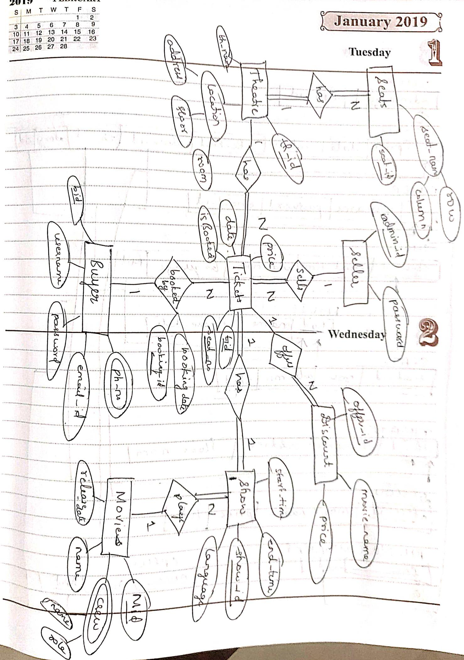

1. **Schema:**

